Computer Language Coding Concepts

Assignment
You will usually not see any direct calls to Get, Set and Use commands. Those system commands are called indirectly by assignment commands. An assignment command executes a Get on one object and a Set on another object, thus yielding over a system aspect from one object to another.

Different aspects have different types of assignment. Below is an overview of the most common types of assignments.

It is also made clear in the overview, which Get, Set and Use commands are called to perform the assignment.

Object-bound aspects and reference-bound aspects are displayed differently. When a reference-bound aspect is Get or Set then the reference is displayed with a parent around it:

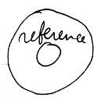

When an object-bound aspect is Get or Set then the targeted object is displayed without a parent around it:

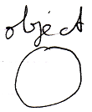

Conventional Assignment Types

Value Assignment

Value Get ←
Value Set →
Copies the value of one object
to another.
Object Assignment
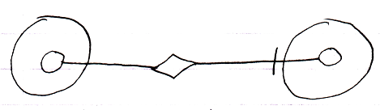
Object Get ←
Object Set →
Makes the target point to
the same object as the source.
So yields over the object aspect.
Class Assignment
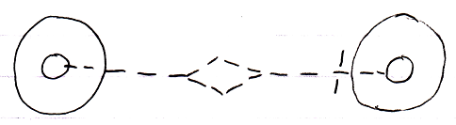
Use As Class ← (~= Object Get)
Class Set →
Turns the source into
the class of the target.

In the assignment notation the line type indicates which aspect is yielded over. The access mark indicates the direction of the assignment.

Value assignment does not require an assignment call symbol, because a Value connection is always an assignment.

See also: System Objects

Author & Copyright: Jan-Joost van Zon Date: July 27, 2009 – August 6, 2009 Location: Oosterhout, The Netherlands Status: Finished

